|  |  |  |  |  |  |
| --- | --- | --- | --- | --- | --- |
| Date | 7-Dec-22 | | | Tester Name | Mohammad Yusuf |
| Environment | Penfax - Test | | | Login used |  |
| Operating System | Windows | Version: | Update: | | |
| Software Used | Select Software | Version: | Update: | | |
| Select Software | Version: | Update: | | |
| Release version |  | | | | |
| Title |  | | | | |
| Test Type | Regression | | | | |
| Test Scenario |  | | | | |
|  |  | | | | |
| Expected Results |  | | | | |
| Pass/Fail | Select | | | JIRA# | N/A |

Describe your steps with screenshots:   
Retired and Married SGIP member

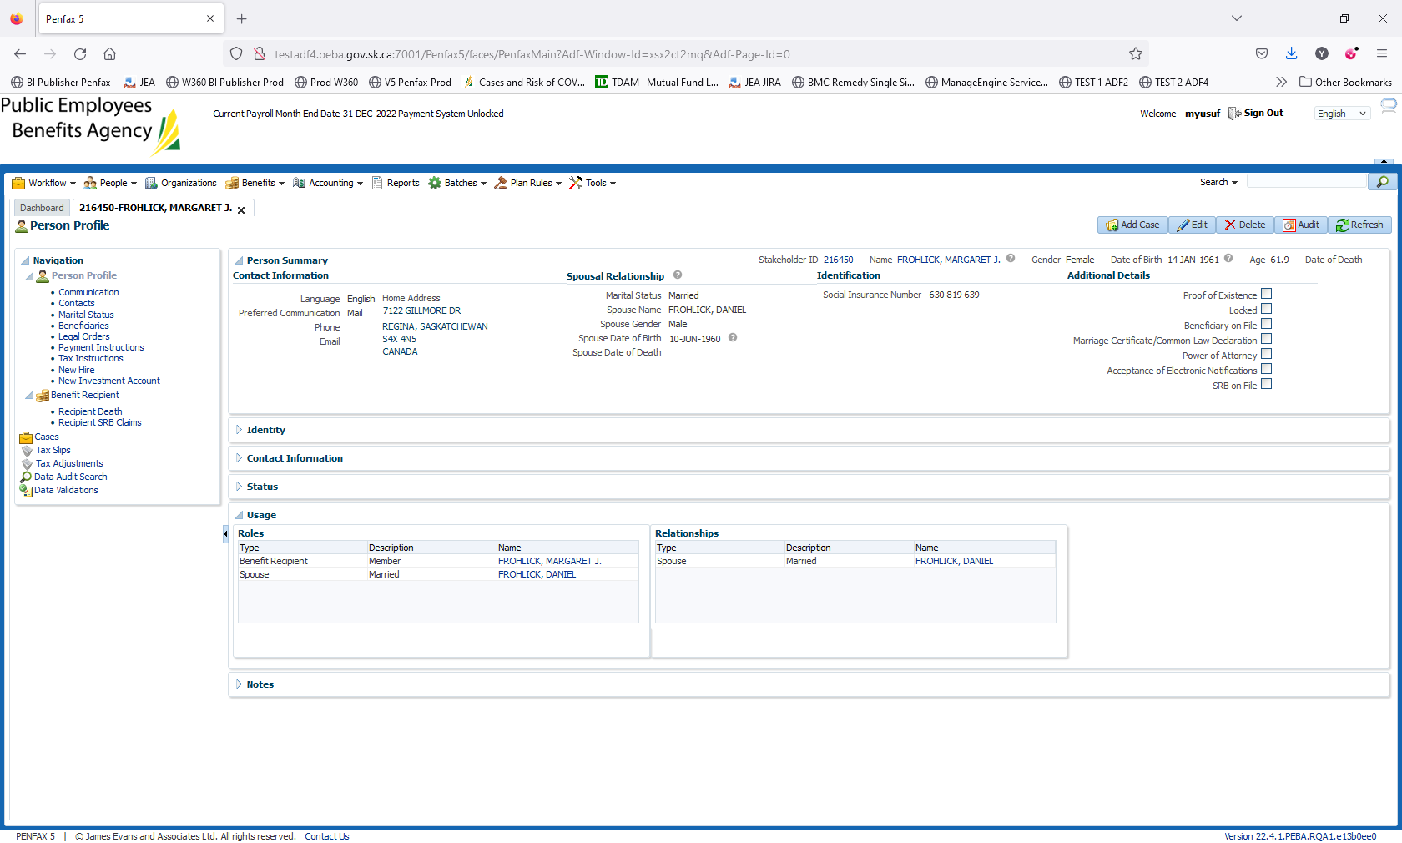

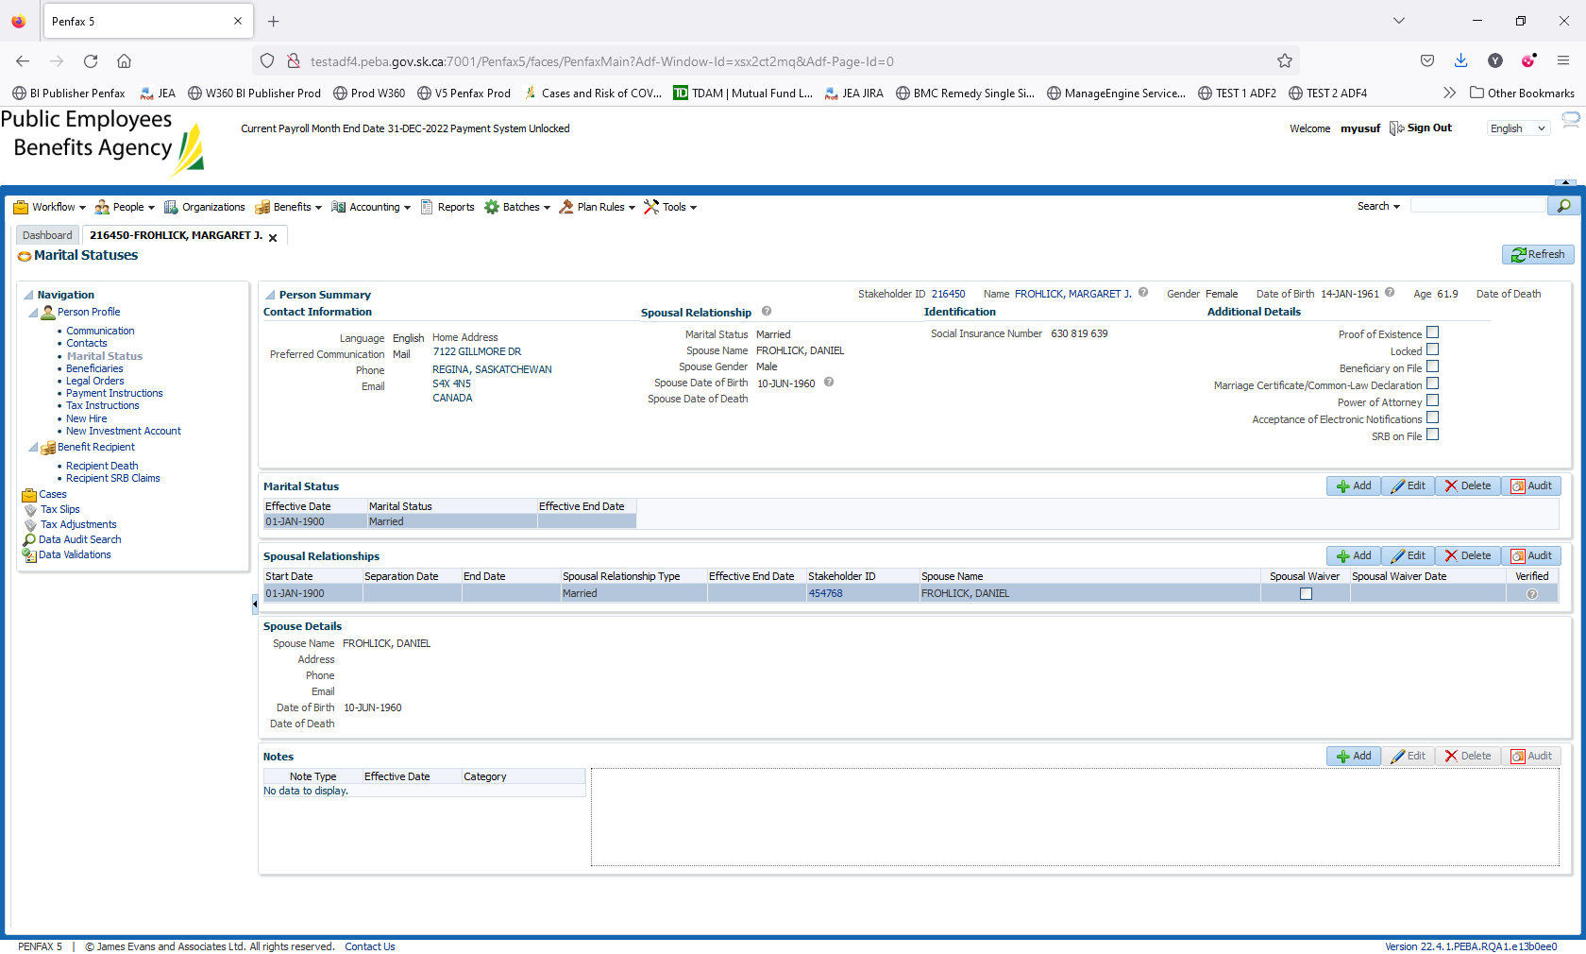

Enter the date of Death. Person Profile – Edit

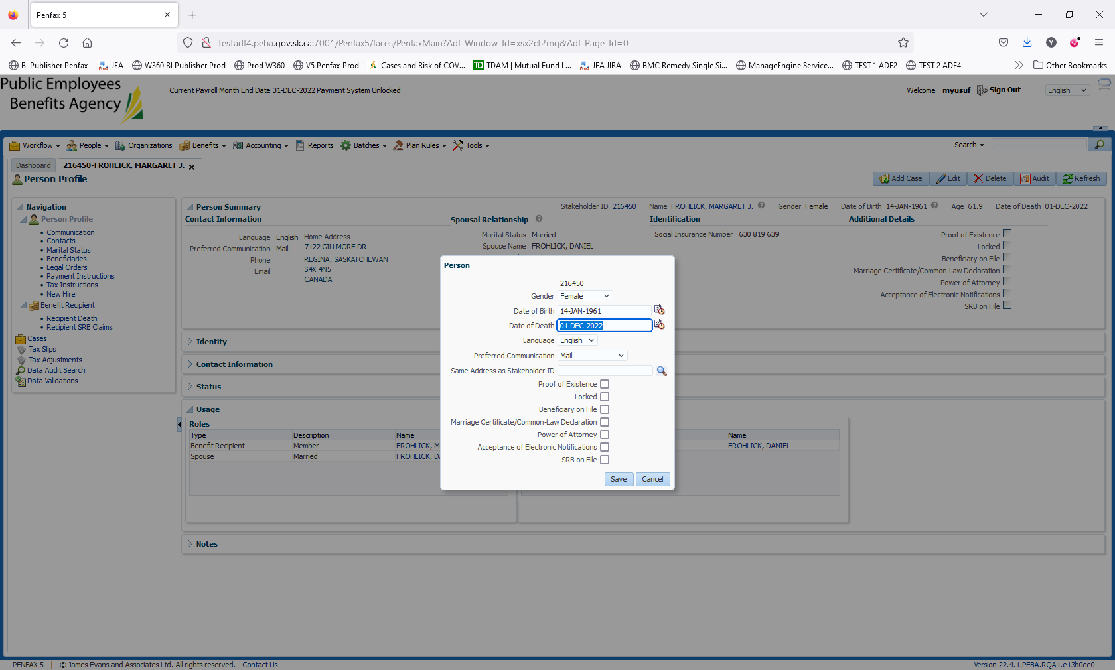

Click Save.

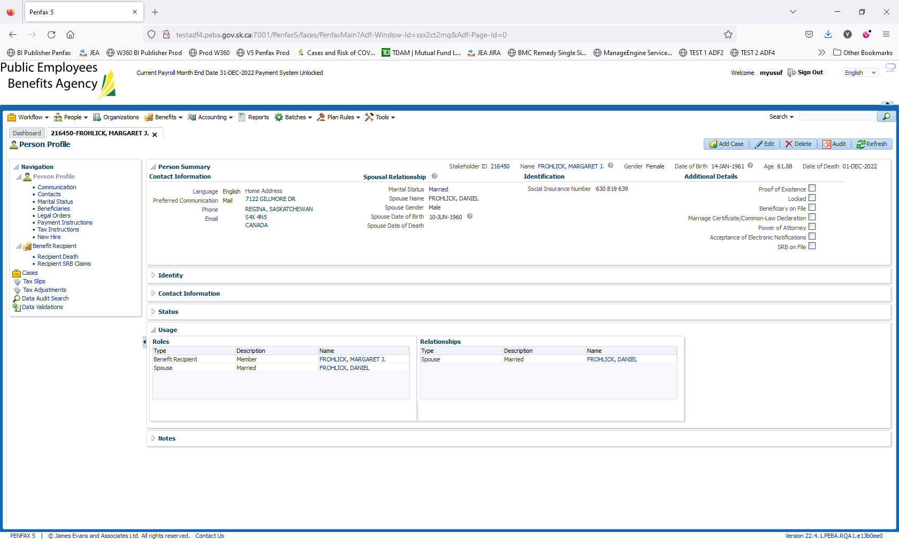

Go to Benefit Recipient -> Recipient Death. Click on New Calculation

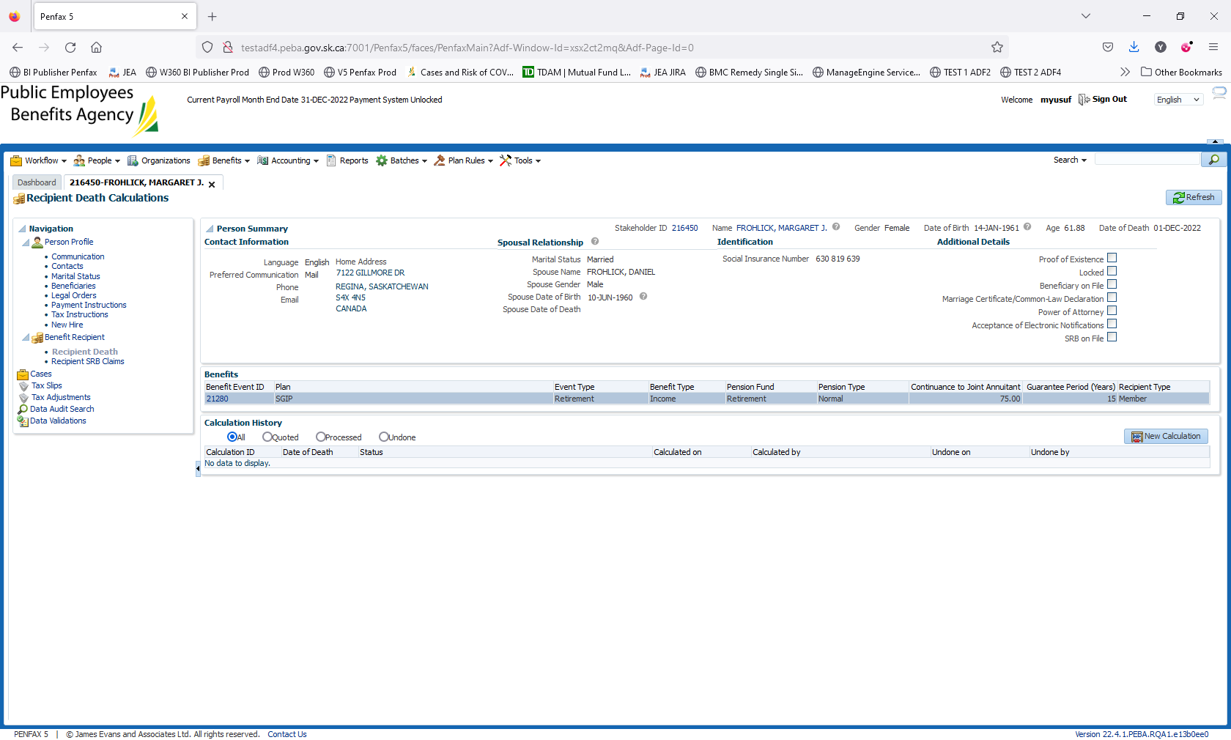

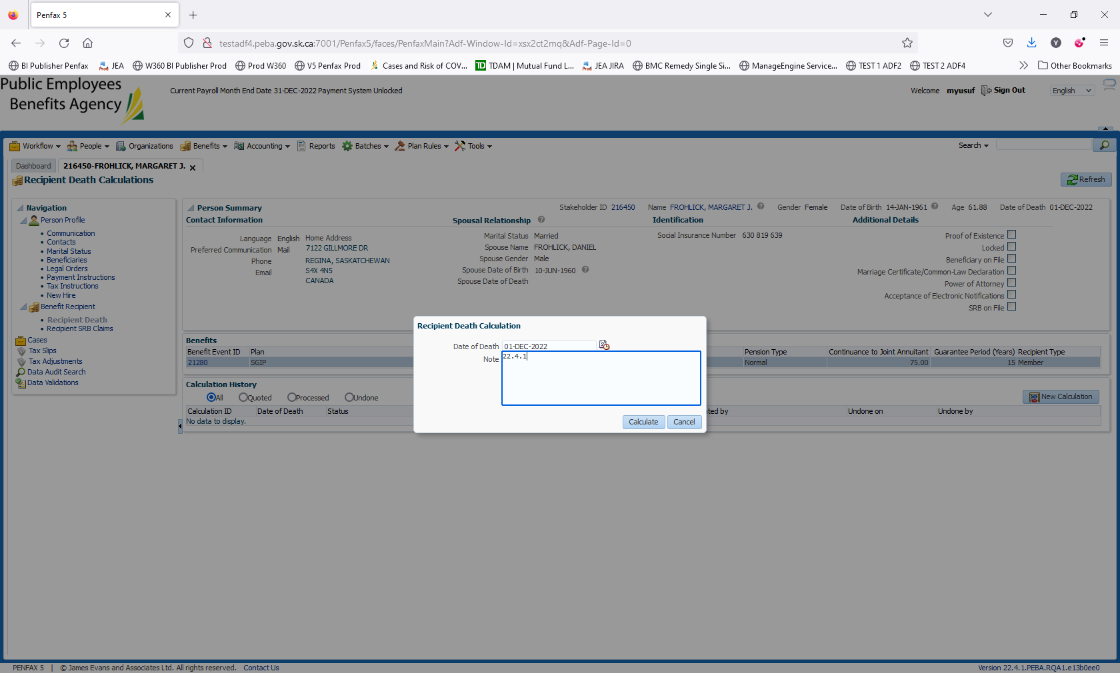

Validate if system is picking the correct Date of Death

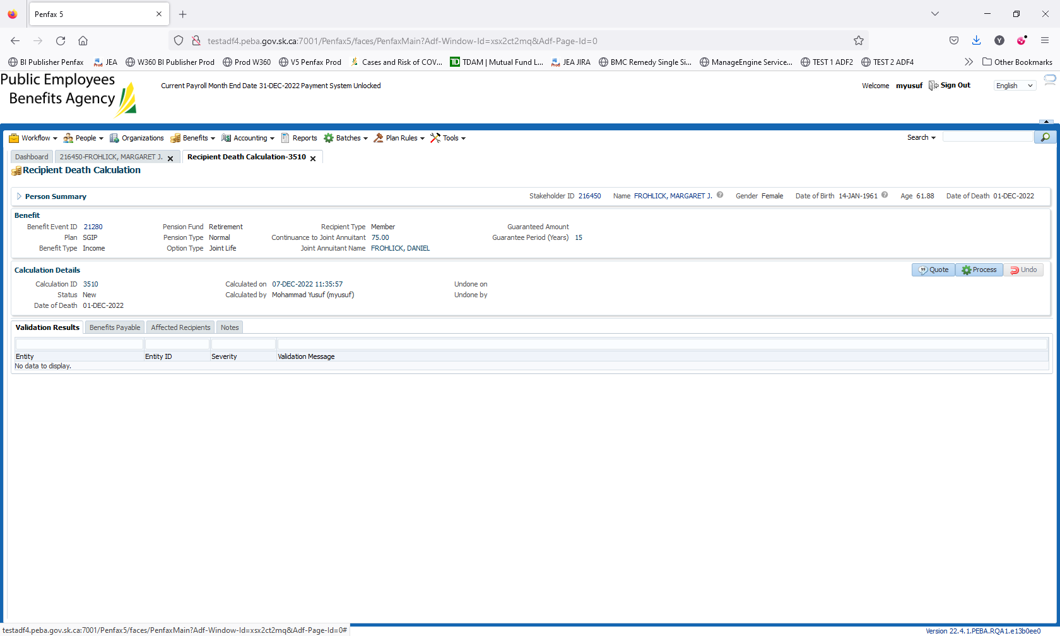

Click on Process

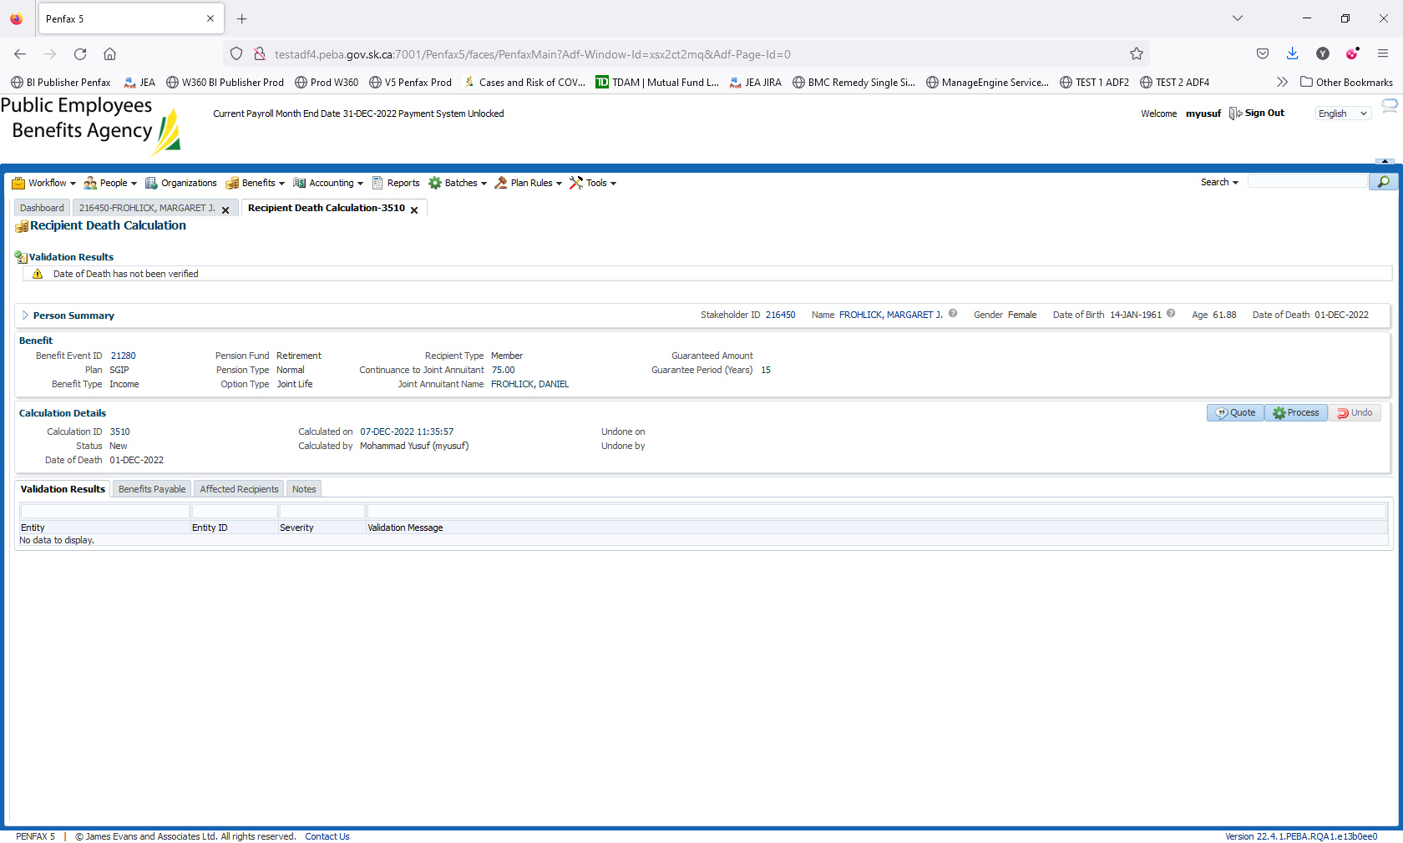

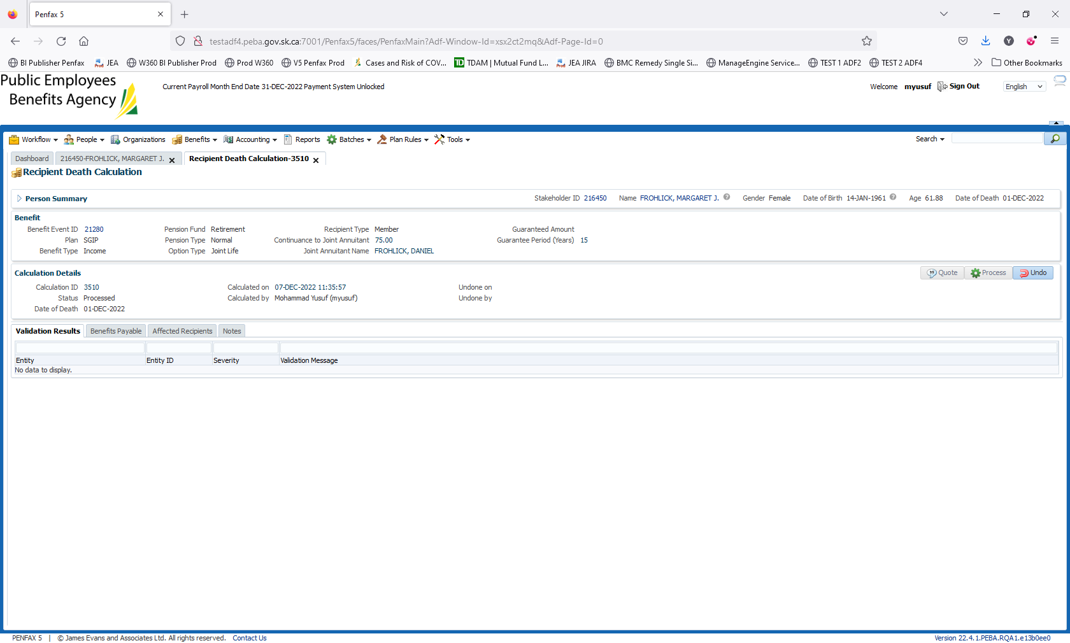

Click on Process again



Open the Benefits Payable tab -> click on Process Recipients

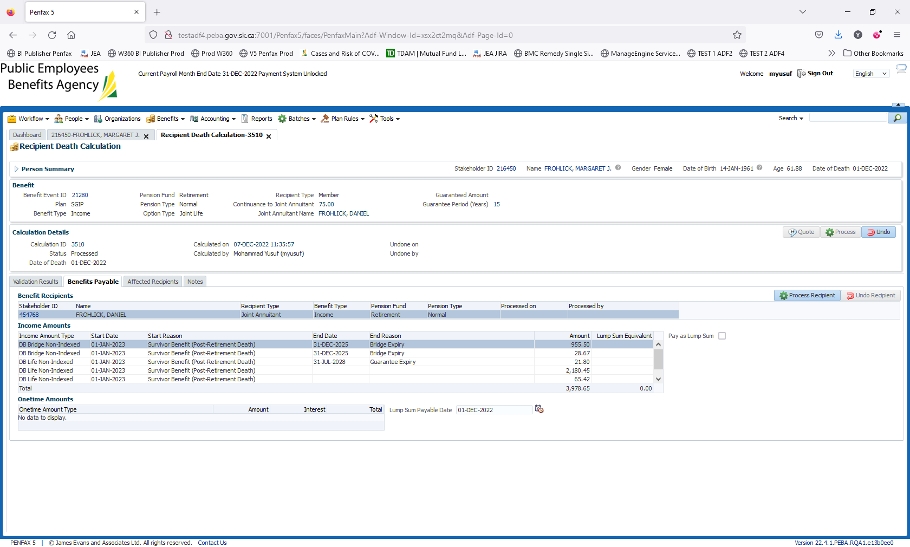

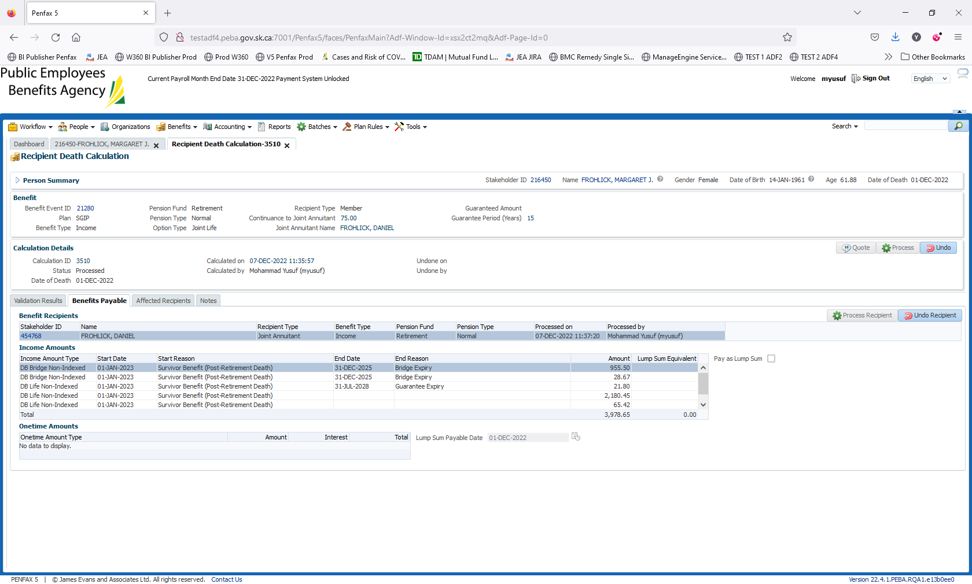

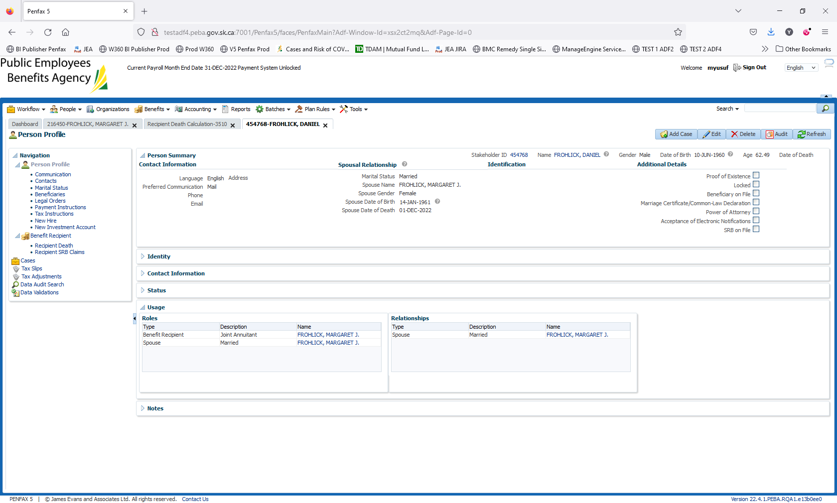

Navigate to Benefit Recipients Stakeholder -> 4547768

Benefit Recipient

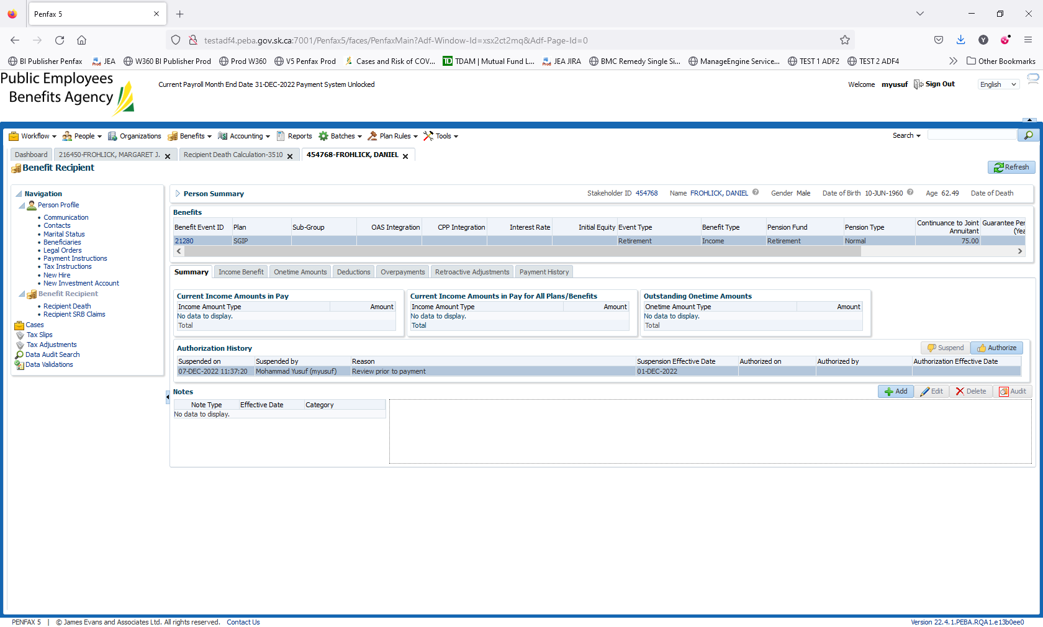

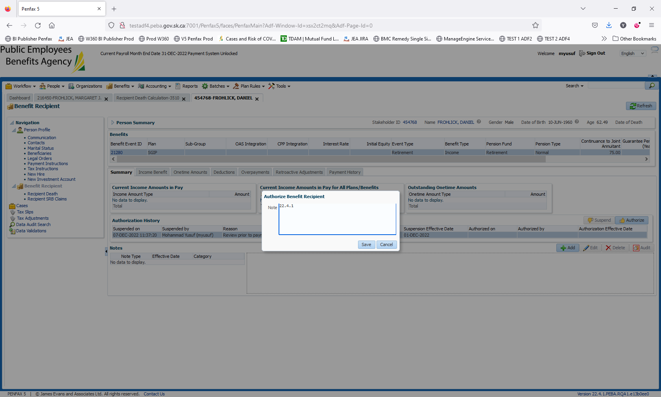

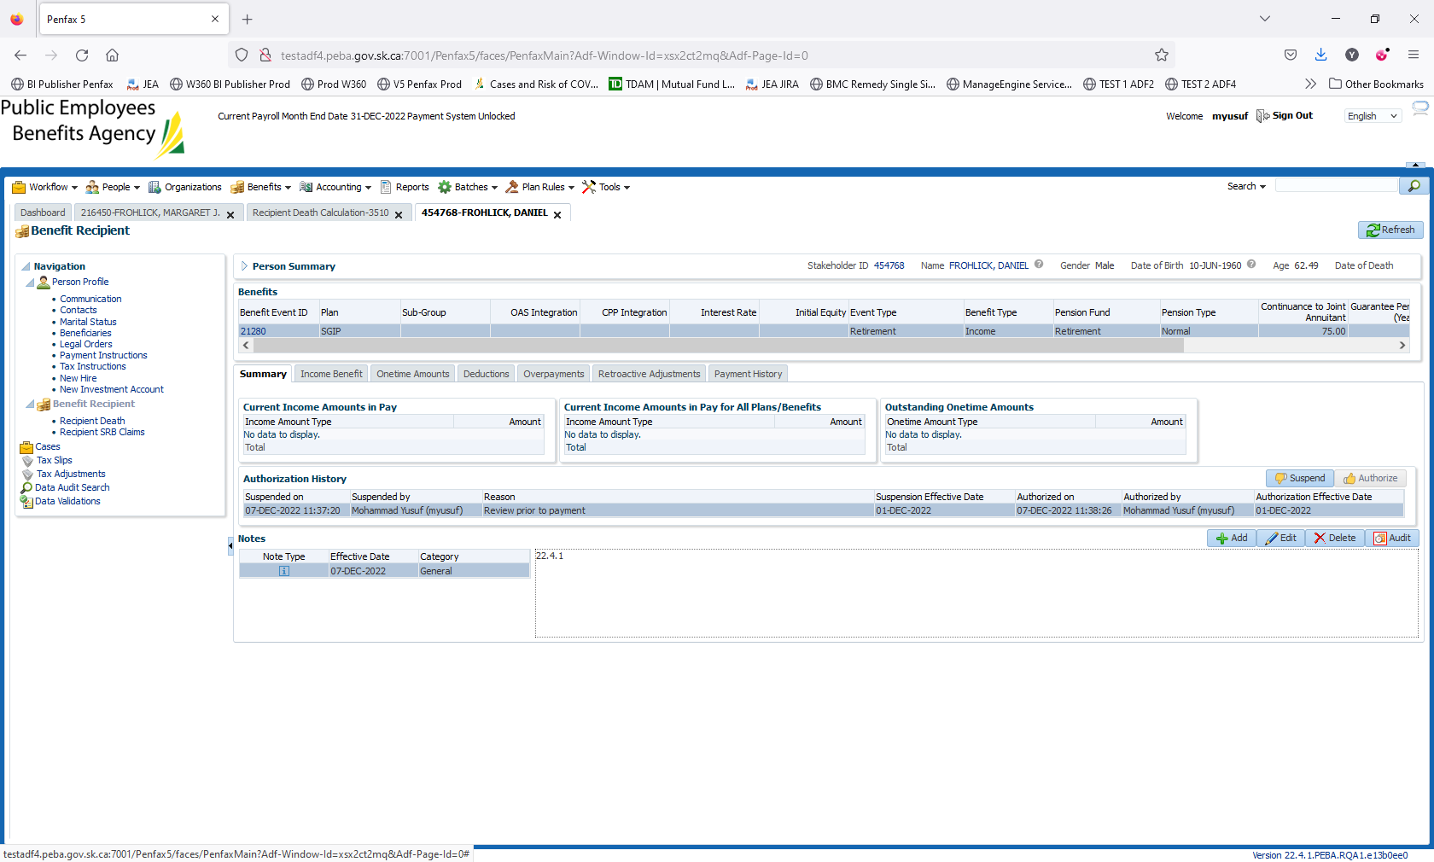

Click on Authorize

Save it

Income is reflected in Spousal section

